**Scheduling Algorithms**

**1. First Come First Serve (FCFS)**

**Sol.-**

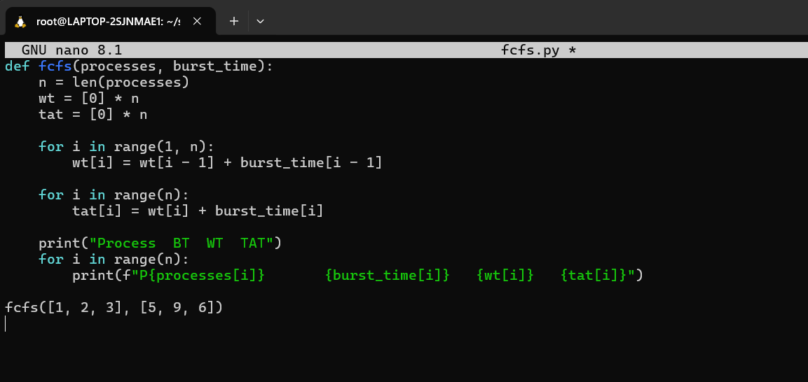

**2. (i) Shortest Job First (SJF) – Non-preemptive**

**Sol. –**

**(ii) Shortest Remaining Time First (SRTF) – Preemptive SJF**

**Sol.-**

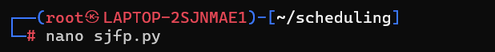

**3. Round Robin (RR)**

**Sol.-**

